Daily Schedules

Having a daily or weekly schedule can be helpful for all of us to stay on track!

It helps us keep the days of the week straight!

Make your own daily or weekly schedule or use one of the templates on the pages that follow or have your child create their own.

Cut out the words below if you want to make your own.

Monday | Tuesday | Wednesday
Thursday | Friday | Saturday
Sunday
Morning | Afternoon | Evening

Breakfast | Lunch | Dinner
Reading | Math | Science
Social Studies | Play games | Free time
Get ready - AM | Get ready - PM

Ideas for a list to help children stay on track and complete the sequence. You can add a picture instead of words or use both! Add in your own words that suit your family needs.

Get Ready - AM
- Wake up
- Wash face
- Brush teeth
- Brush/comb hair
- Get dressed

Get Ready - PM
- Wash face
- Brush teeth
- Pajamas
- Read a story

Some Pictures:
Breakfast | Lunch | Dinner
 | Dance party! |  | Exercise | 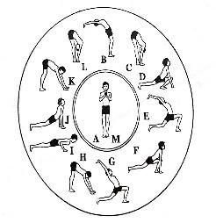  Yoga Poses
Coloring  Pages | 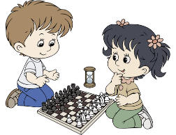  Play  games | Drawing | Work  time | Shower/Bath
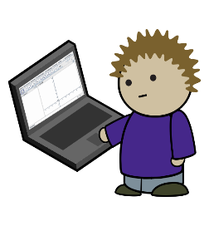 | Read | Get dressed | 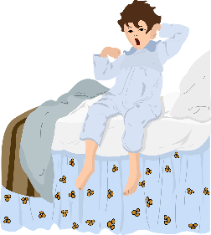 | Brush  Teeth
Screen Time or  Computer Work |  |  | Wake Up or  Time for bed

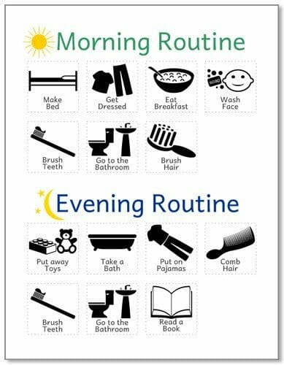

Schedule Templates:
*Can be done on a Daily and Weekly Style
*Can be done as a chart tracking way, add stickers, check marks or smiley faces when completed.
*Do what works for your family.

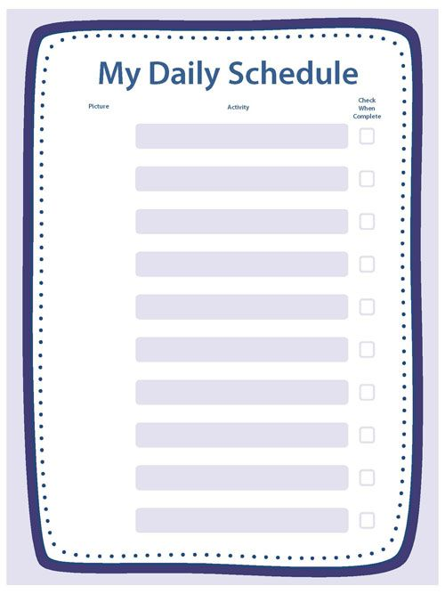

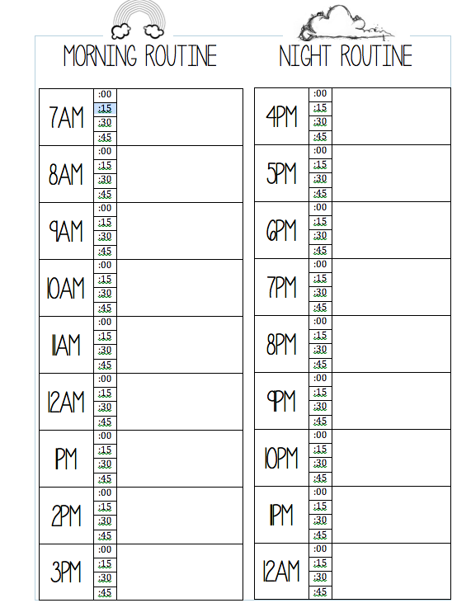

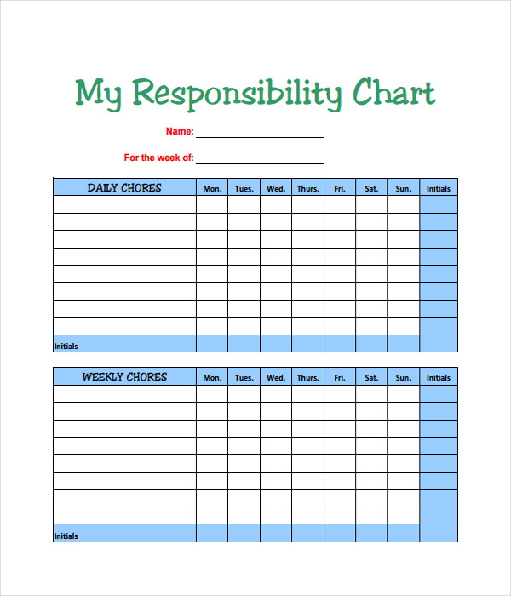
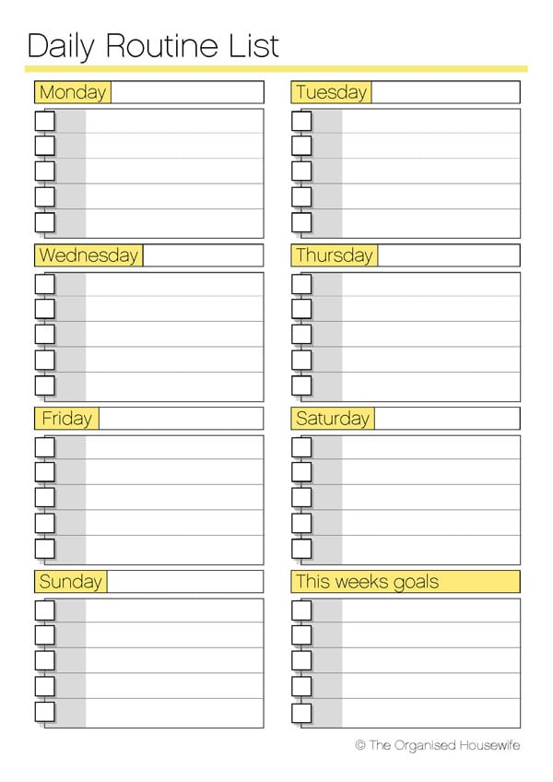

Weekly Schedule Template
 | MORNING | AFTERNOON | EVENING
Monday | Wake up /Get ready | Math page | Drawing, Coloring, Writing
23 | Breakfast | Play outside or build indoor obstacle course | Play Games or other activity
 | Read or listen to a story | lunch | Dinner
Tuesday
24

This weekly sample is added on at the end of this document as a whole week page (scroll further).

You can add in the numbers for each day/date and choose a few things for the sections in each day.

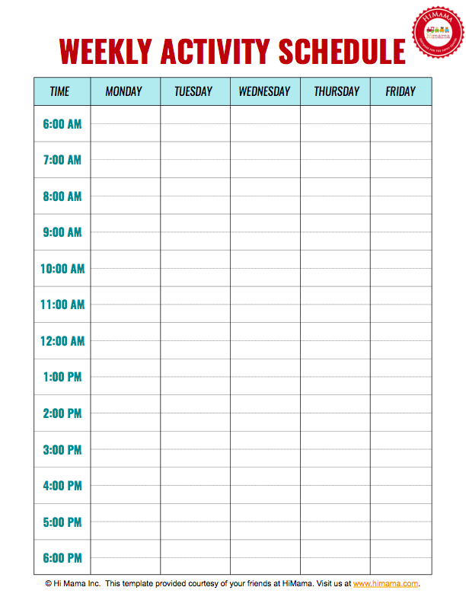

Weekly Schedule Template

 | MORNING | AFTERNOON | EVENING
Monday
Tuesday
Wednesday
Thursday
Friday
Saturday
Sunday

